Dates to remember 2024

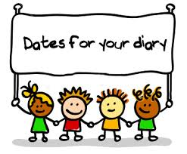

2nd & 3rd October – Inset day - Nursery is closed

4th October - Children back to school

1st October – Black History

5th October – National Teachers Day

6th October – Grandparents Day

21st- 25th October - Half term – Nursery is closed

28th October- Nursery re-opens

27th October, British summer time ends, clocks go back 1hr.

**Our Poetry Basket poem for the month.**



Do a dance say’s one foot.  
Other foot say’s lets jiggle.  
Hands say’s clap, slappity slap.  
And all of me say’s wriggle.

**Home Learning:**

The children are to learn the words of the poem daily. (a video will be posted in the WhatsApp group to help)  
Can you do the actions?  
Brilliant! now let’s see you put the words and actions together.  
  
Please record and post on tapestry.



**Wow**, what a summer we had, filled with rain and sunshine.

What did you do over the summer holiday? What amazing adventures did you go on?

Maybe a trip to the park or the seaside, a visit to see family and make some wonderful memories. What transportation did you take? Plane, Bus, Car or Train.

Draw a picture of something that made your summer holiday AMAZING!



Children's Centre: Chatterbox

Chatterbox groups are for families with children aged 4 and under who have concerns about their child’s talking or interaction.

Chatterbox offers targeted groups in children’s centres to promote, support and encourage children’s speech, language, and communication development in pre-school aged children.

For venues and times of sessions please contact:

Selhurst Children’s Centre

0208 684 3777 option 1

[childrenscentres@scc.croydon.sch.uk](mailto:childrenscentres@scc.croydon.sch.uk)

+-

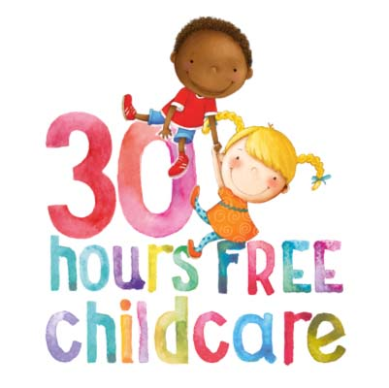



Black History Month is a time when we celebrate influential people who made important contributions to the world.

On Tuesday 1st October 2024, the children may dress up as one of the famous historic leaders, champions, and inventors.

People such as Malcolm X, Rosa Parks, Mary Seacole, Usain Bolt and many more.

Research and learn about your chosen hero.

There will be a prize for best dressed.  
*********** 3hours FREE! *****************

Did you know the first-ever person to invent traffic lights was Garrett Morgan?



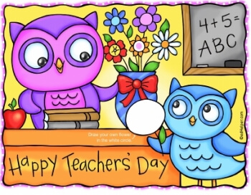

Although this is the parent’s newsletter, please allow me to thank our teachers at the Hop, Skip, and Jump Nursery branch.

Your dedication, hard work, love and care for the children, and supporting our amazing parents have not gone unnoticed.

Thank you, Teachers Subha and Ewelina.  
  
I would also like to thank Mrs T, who will be covering for me during my absence.  
  
I will be back on the 12th of September, any enquiries please see Deputy Ewelina or Subha.

Are you eligible for 30 hours? Not sure?   
Scan the QR code with your mobile camera  
and will bring you to the website to apply.



Alternatively, copy and paste the link below.

https://www.gov.uk/30-hours-free-childcare

For working parents of children aged 3-4 years old



Sunday 6th October 2024 is Grandparents Day.

From Monday 7th to the 9th of October 2024, grandparents are invited to read a story or join in with our arts and craft sessions, for 30 minutes.

The time is from 10.30 am to 11 am.  
During the 30 minutes, you may leave at any time, if you do not wish to stay for the full half an hour.

This will take place in the large hall.   
Please inform a member of staff the week before if you wish to take part.